**CREATE NODE RED**

|  |  |
| --- | --- |
| **TEAM ID** | **PNT2022TMID43096** |
| **PROJECT NAME** | **GAS LEAKAGE MONITORING AND ALERTING SYSTEM FOR INDUSTRIES** |

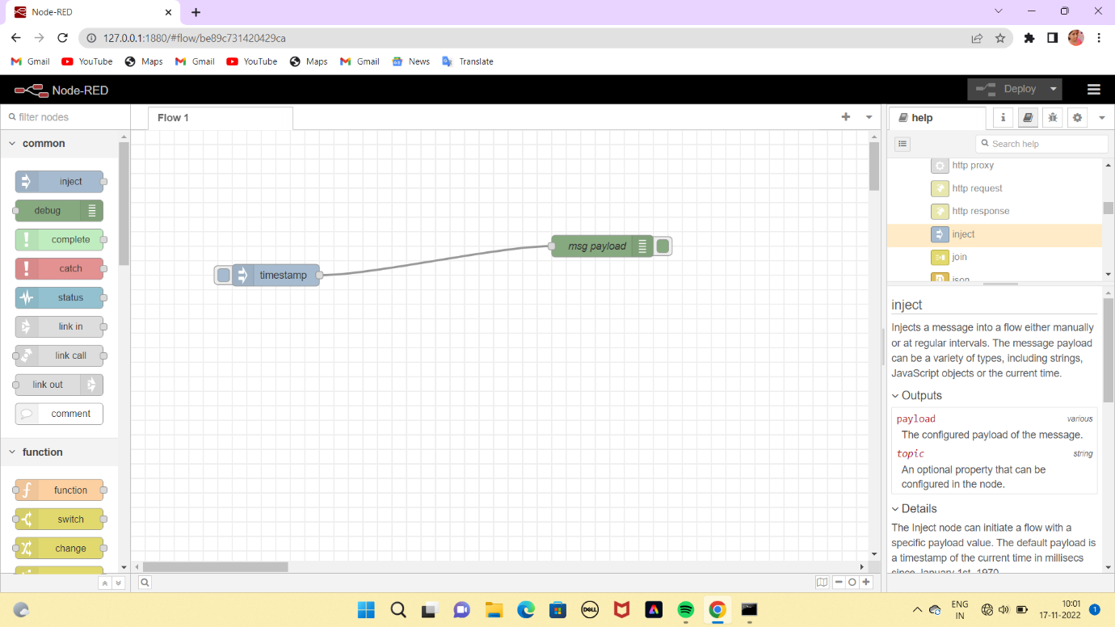

**RESULT:**

Created NODE-RED service.